Bug ID: BUG-001
- Title: Error message does not specify invalid username
- Description: When logging in with invalid username and valid password, Error message does not specify invalid username
Steps: 1-open the website https://www.saucedemo.com/v1/
2-enter at username field "asmaa_arafa"
3-enter at passwared field "secret_sauce"
4-click on login button
- Expected Result: Error message: “Epic sadface: Username do not match any user in this service.”
- Actual Result: Epic sadface: Username and password do not match any user in this service.
- Priority: Medium
- Severity: Minor
- screen shots
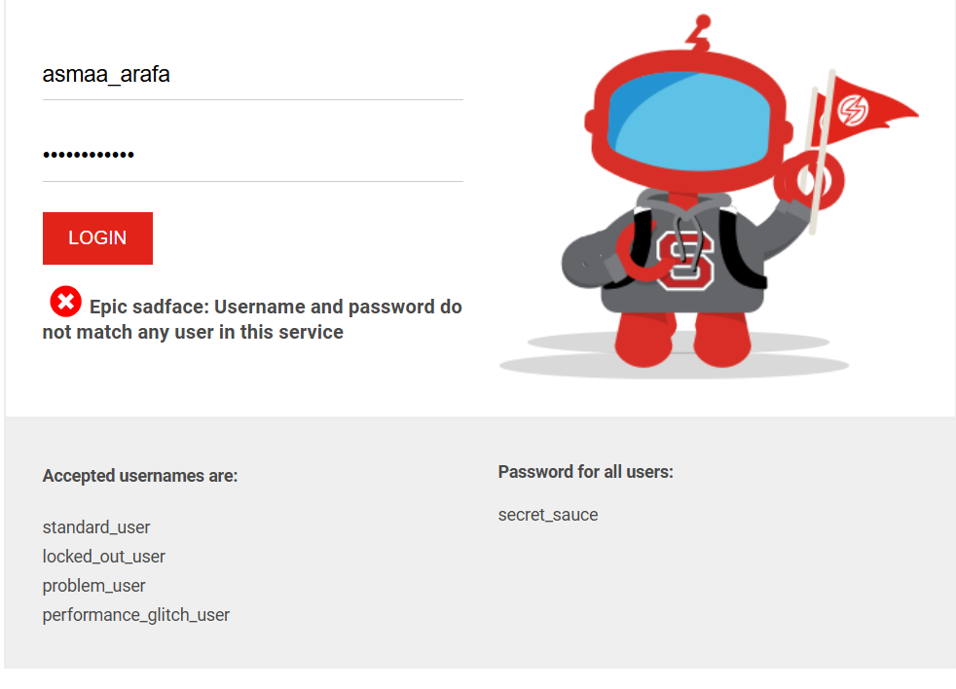
---

Bug ID: BUG-002
- Title: Error message does not specify invalid passwared
- Description: When logging in with valid username and valid inpassword, Error message does not specify invalid passwared
- Steps: 1-open the website https://www.saucedemo.com/v1/
2-enter at username field "standard_user"
3-enter at passwared field "abs_asd"
4-click on login button
- Expected Result: Error message: “Epic sadface: Password is incorrect.”
- Actual Result: Epic sadface: Username and password do not match any user in this service.
- Priority: Medium
- Severity: Minor
- Screenshots:
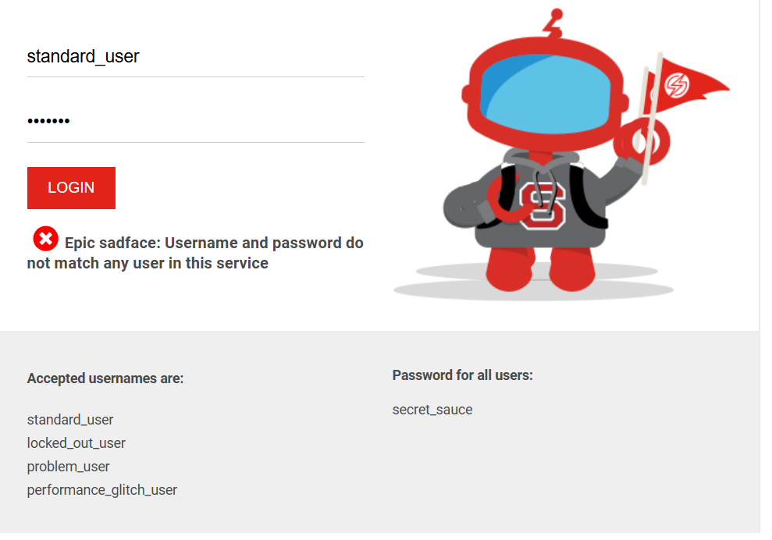
---

Bug ID: BUG-003
- Title: Both fields empty shows only username error
- Description: When leaving both username and password empty, system only shows username required
- Steps: 1-open the website https://www.saucedemo.com/v1/
2-leave username field empty
3-leave passwared field empty
4-click on login button
- Expected Result: Error message: “Epic sadface: Username and passwared is required.”
- Actual Result: Error message: “Epic sadface: Username is required.”
- Priority: High
- Severity: Major
- screenshot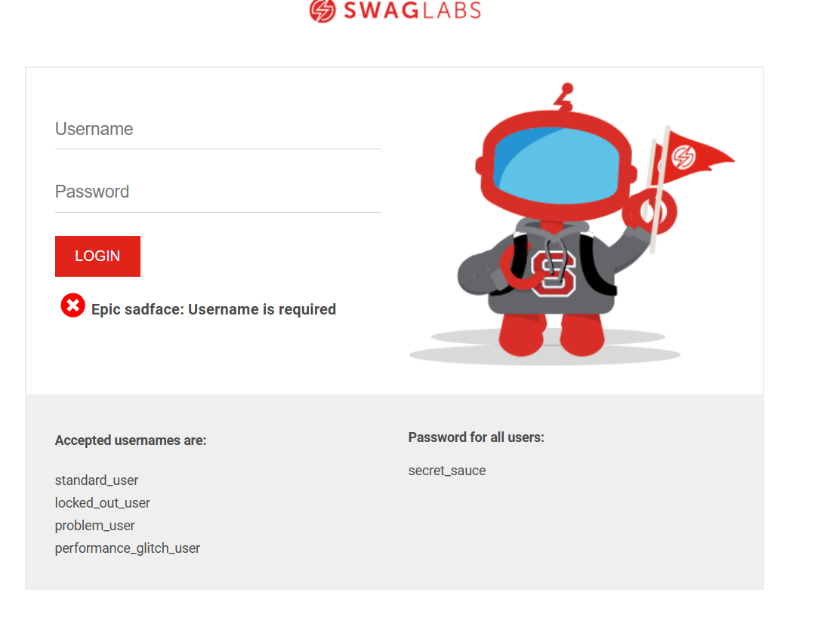
---

Bug ID: BUG-004
- Title: Error message does not specify invalid username when special character
- Description: when enters a username containing extra special characters Error message does not specify invalid username
- Steps: 1-open the website https://www.saucedemo.com/v1/
2-enter at username field "standard_user@@"
3-enter at passwared field "secret_sauce"
4-click on login button
- Expected Result: Error message: “Epic sadface: Username do not match any user in this service.”
- Actual Result: Epic sadface: Username and password do not match any user in this service.
- Priority: Medium
- Severity: Minor
- Screenshot:
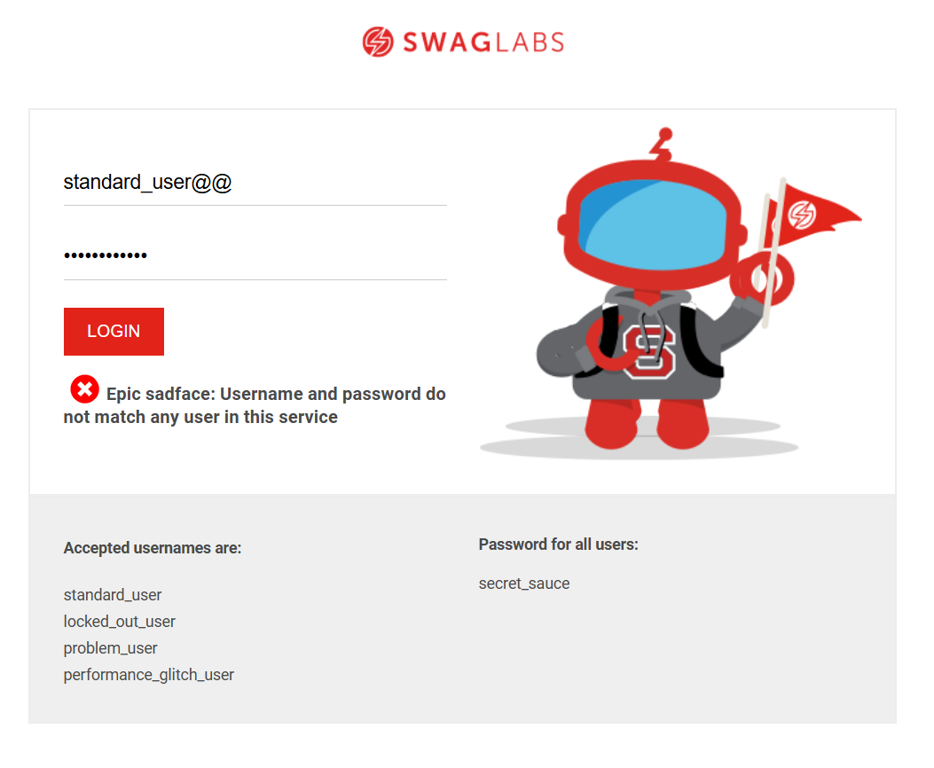---

Bug ID: BUG-005
- Title: Error message does not specify invalid passwared when special character
- Description: when enters a passwared containing extra special characters Error message does not specify invalid username
- Steps: 1-open the website https://www.saucedemo.com/v1/
2-enter at username field "standard_user"
3-enter at passwared field "secret_sauce@@"
4-click on login button
- Expected Result: Error message: “Epic sadface: Password is incorrect.”
- Actual Result: Epic sadface: Username and password do not match any user in this service.
- Priority: Medium
- Severity: Minor
- Screenshot:
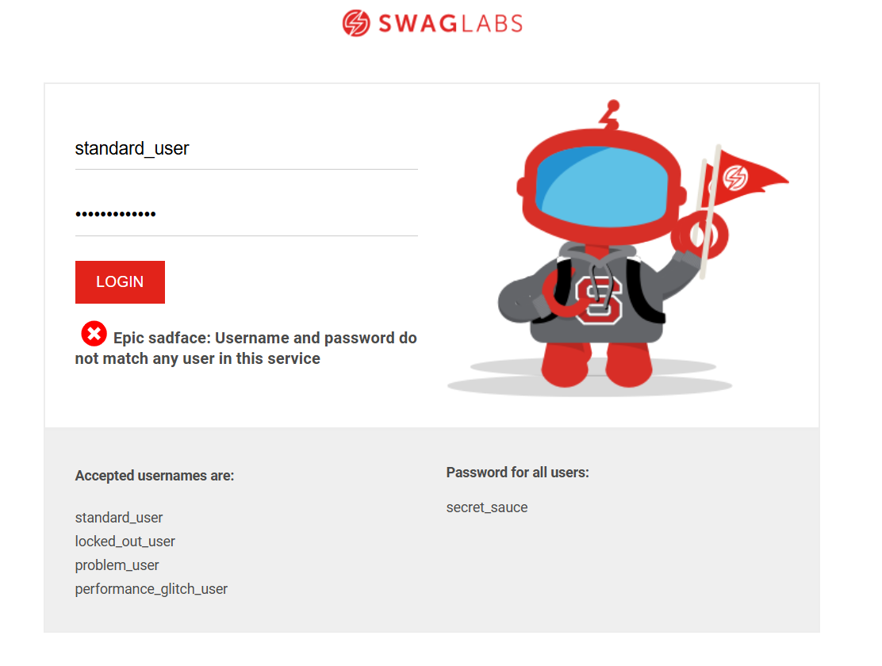---

Bug ID: BUG-006
- Title: Error message does not specify invalid username when enter capital character
- Description: when enters a username with capital characters Error message does not specify invalid username
- Steps: 1-open the website https://www.saucedemo.com/v1/
2-enter at username field "STANDARED_USER"
3-enter at passwared field "secret_sauce"
4-click on login button
- Expected Result: Error message: “Epic sadface: Username do not match any user in this service.”
- Actual Result: Epic sadface: Username and password do not match any user in this service.
- Priority: Medium
- Severity: Minor
- Screenshot: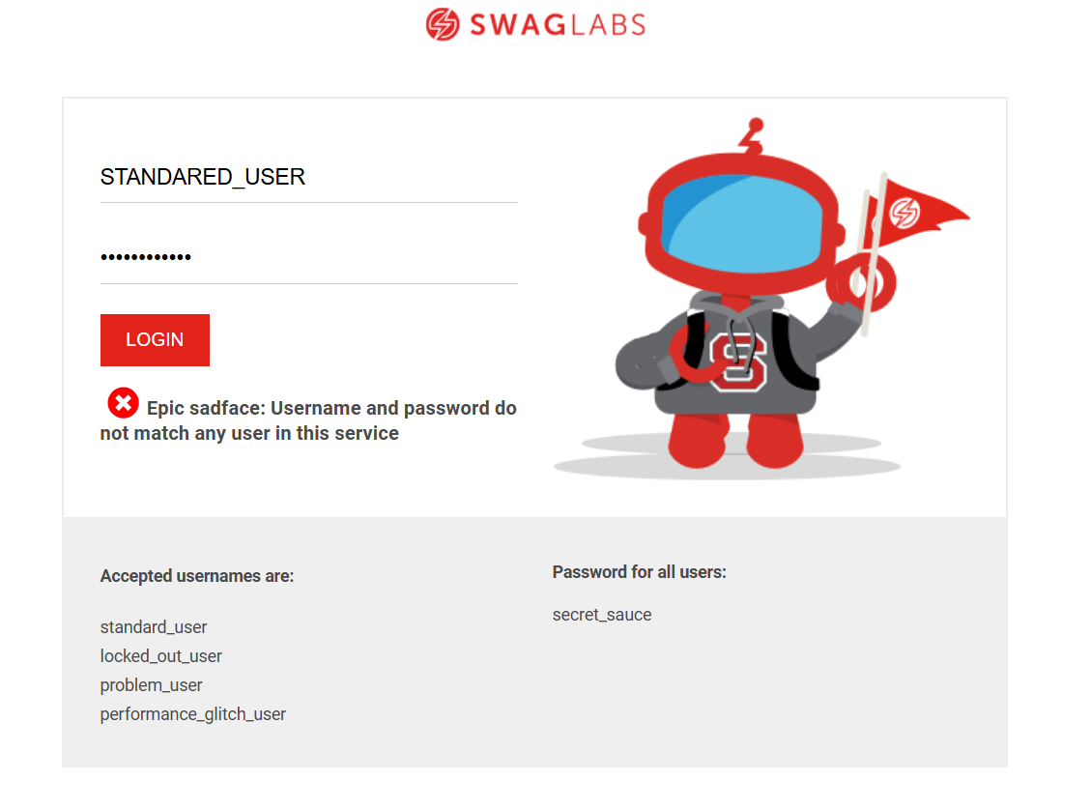---
Bug ID: BUG-007
- Title: Error message does not specify passwared invalid capital when enter capital character
- Description: when enters a passwared with capital characters Error message does not specify invalid passwared
- Steps: 1-open the website https://www.saucedemo.com/v1/
2-enter at username field "standard_user"
3-enter at passwared field "SECRET_SAUCE"
4-click on login button
- Expected Result: Error message: “Epic sadface: Password is incorrect.”
- Actual Result: Epic sadface: Username and password do not match any user in this service.
- Priority: Medium
- Severity: Minor
- screenshot
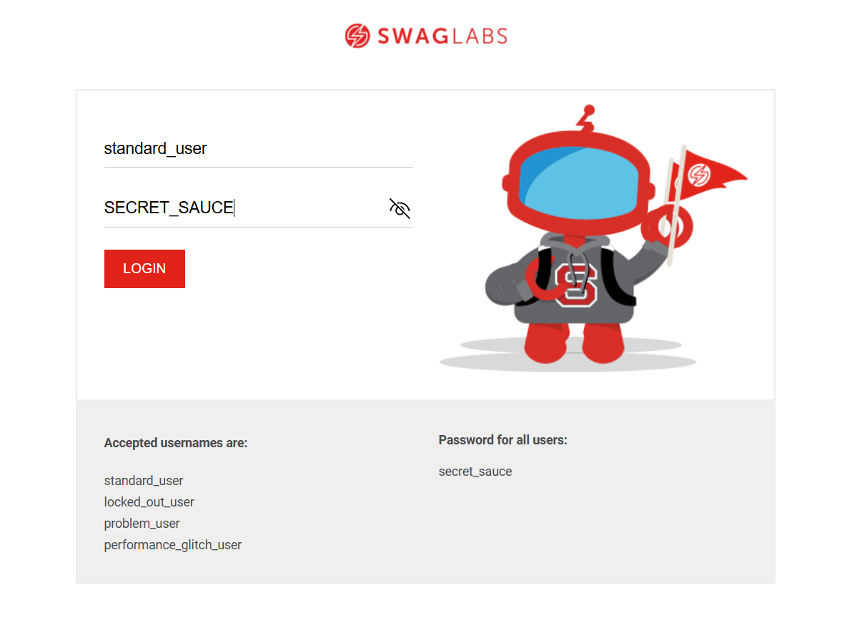

---
Bug ID: BUG-008
- Title: Error message does not specify invalid username when Enter 14 spaces
- Description: when Enter 14 spaces at username with valid passwared Error message does not specify invalid username
- Steps: 1-open the website https://www.saucedemo.com/v1/
2-enter at username field " "
3-enter at passwared field "secret_sauce"
4-click on login button
- Expected Result: Error message: “Epic sadface: Username do not match any user in this service.”
- Actual Result: Epic sadface: Username and password do not match any user in this service.
- Priority: Medium
- Severity: Minor
- Screenshot:
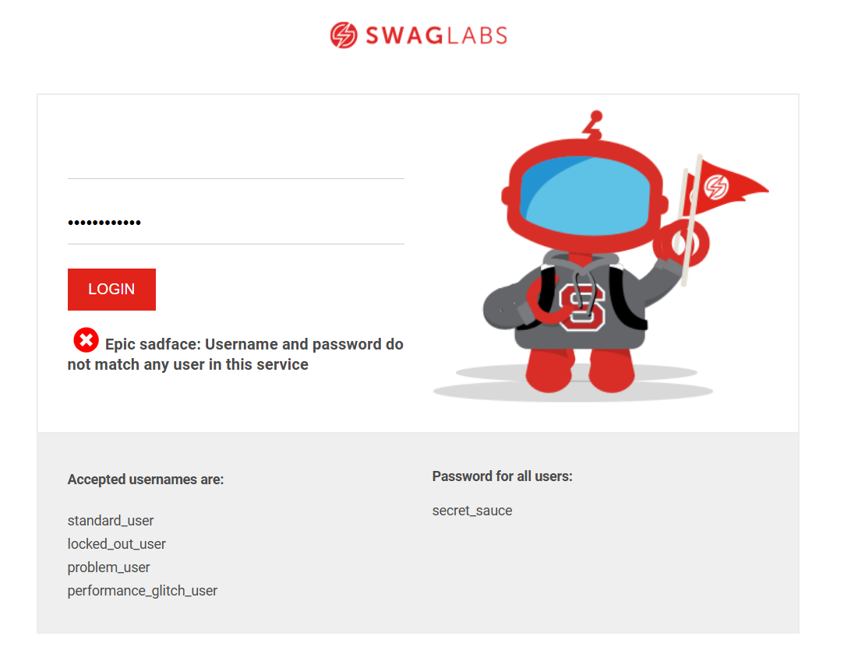---

Bug ID: BUG-009
- Title: Error message does not specify invalid passwared when Enter 12 spaces at passwared field with valid username
- Description: when Enter 12 spaces at passwared field with valid username Error message does not specify invalid passwared
- Steps: 1-open the website https://www.saucedemo.com/v1/
2-enter at username field "standard_user"
3-enter at passwared field " "
4-click on login button
- Expected Result: Error message: “Epic sadface: Password is incorrect.”
- Actual Result: Epic sadface: Username and password do not match any user in this service.
- Priority: Medium
- Severity: Minor
- Screenshot:
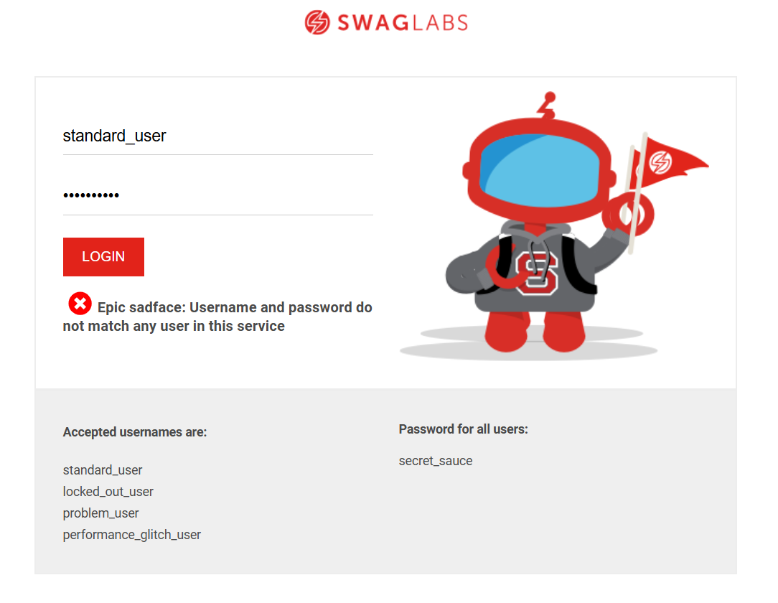
---

Bug ID: BUG-010
- Title: Error message does not specify invalid username when add 3 spaces after valid standared user name with valid passwared
- Description: when add 3 spaces after valid standared user name with valid passwared Error message does not specify invalid username
- Steps: 1-open the website https://www.saucedemo.com/v1/
2-enter at username field "standard_user "
3-enter at passwared field "secret_sauce"
4-click on login button
- Expected Result: Error message: “Epic sadface: Username do not match any user in this service.”
- Actual Result: Epic sadface: Username and password do not match any user in this service.
- Priority: Medium
- Severity: Minor
- Screenshot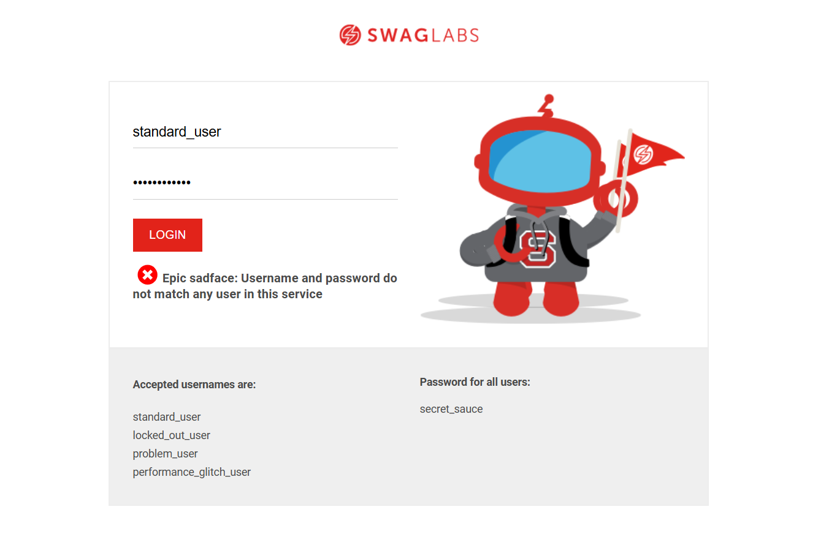
---

Bug ID: BUG-011
- Title: Error message does not specify invalid passwared when add 3 spaces after valid passwared with valid username
- Description: when add 3 spaces after valid passwared with valid username Error message does not specify invalid username
- Steps: 1-open the website https://www.saucedemo.com/v1/
2-enter at username field "standard_user"
3-enter at passwared field "secret_sauce "
4-click on login button
- Expected Result: Error message: “Epic sadface: Password is incorrect.”
- Actual Result: Epic sadface: Username and password do not match any user in this service.
- Priority: Medium
- Severity: Minor
- Screenshot:
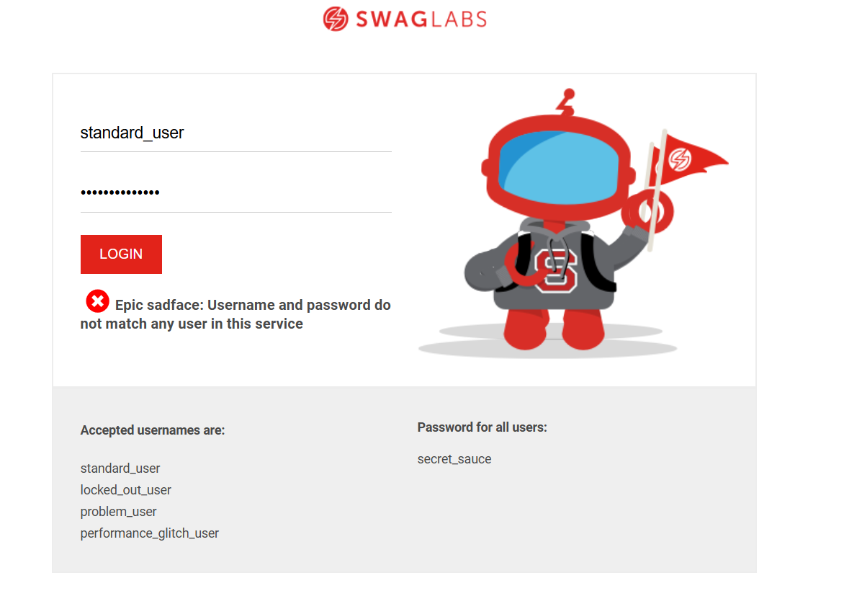

---

Bug ID: BUG-012
- Title: Product images broken for problem_user
- Description: when login with problem user Products page loads with hidden images
- Steps: 1-open the website https://www.saucedemo.com/v1/
2-enter at username field "problem _user"
3-enter at password field "secret_sauce "
4-click on login button
- Expected Result: Login succeeds → Products Page opens and The images will appear correct.
- Actual Result: Products page loads with correct images
- Priority: High
- Severity: Critical
- Screenshot:
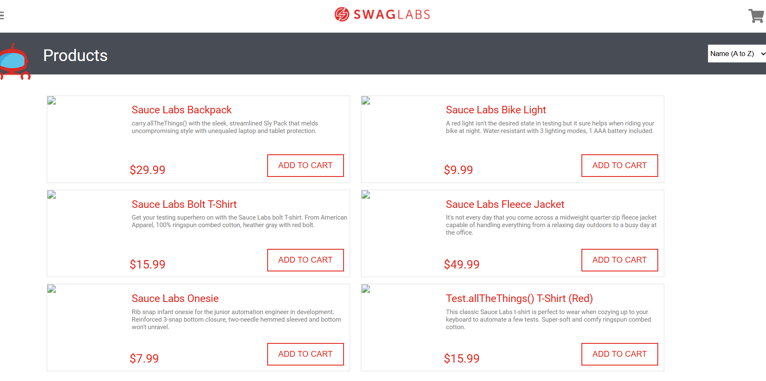

---

Bug ID: BUG-013
- Title: Login with performance_glitch_user causes delay
- Description: when login withperformance_glitch_userProducts page loads slowly
- Steps: 1-open the website https://www.saucedemo.com/v1/
2-enter at username field "performance_glitch_user"
3-enter at passwared field "secret_sauce "
4-click on login button
- Expected Result: Login succeeds → Products Page opens directly
- Actual Result: Login succeeds → Products Page opens directly but with delay
- Priority: High
- Severity: Major
- screen record:

---

